To reduce the file size, you may wish to try the following methods:

* You can reduce file size by doing the following steps in the Adobe Acrobat Reader:   
  **In Acrobat Reader**, choose **File**> **Save As Other** > **Reduced Size PDF**
* When you scan or take pictures of the documents, please **ensure that the resolution is set at a lower resolution**. E.g. 150dpi resolution.
* To ensure that the documents are clearly captured, we recommend the use of  **Microsoft Office Lens – PDF Scanner** (recommended app to use for scanning the documents- refer to [step-by-step guide](https://www.nyp.edu.sg/content/dam/nyp/admissions/full-time-diploma/financial-matters-financial-assistance/march2020/userguideformicrosoftlens.pdf))
* **Compress Images in PowerPoint**. Select the image you want to compress, and then:

1. Go up to the **Picture Tools Format**tab
2. Click on the **Compress Pictures** command and Select your **Compression options**
3. Select your **Resolution,** Click **OK**

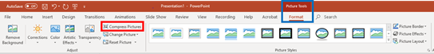

1. **Save PowerPoint as PDF files (**File > Save As > Save As Type > Select PDF)

* **How to compress and zip a folder / file**

For Window’s instructions, please refer to: <https://support.microsoft.com/en-> sg/help/14200/windows-compress-uncompress-zip-files

For Mac’s instruction, please refer to: <http://www.macinstruct.com/node/159>.